**Class 15 - Content: Reading strategies for technical texts**

I – Objective: Understanding and using reading strategies in technical texts

Our last content is about reading strategies for technical texts; instead of proposing you a text in your field of studying you are going to search a text for reading. The task is divided in some steps:

-In pairs or groups of 3 you have to prepare a creative presentation using the Padlet tool, which is an interactive and collaborative virtual mural.



Using the following sites, you can find a tutorial on how to create a Padlet or you can use another site explaining how to use it.

<https://drive.google.com/file/d/12G6hzXNfzhtBmH9iMAhfy6VJdDTH4aZD/view?usp=drive_link>

<https://www.youtube.com/watch?v=9iXVTi3Uovs>

-You can use several kinds of resources as videos, images, texts, links to create your presentation based on the text you selected to read. When you finish your task, you have to send the link of the Padlet to our WhatsApp group, containing the students’ names. For each content you prepare, add a space for comments.

-When all the groups have sent the links, each student has to comment at least one presentation identifying his/her name. Non-identifying comments will not be evaluated/assessed. One comment must be positive and the other should present something to be improved.

-The activity is worth 3.0 points, being 2.0 for the group presentation and 1.0 for the comments.

**Class 16 - Content: Reading strategies for technical texts**

I – Objective: Understanding and using reading strategies in technical texts

Preparing and analysing the Padlets

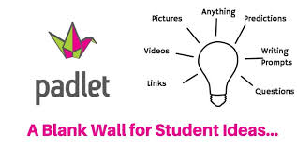

(from <https://padletcommunicationtoolit648.weebly.com/instructional-strategy.html>)

**Class 17 - Content: Reading strategies for technical texts**

I – Objective: Understanding and using reading strategies in technical texts

Assessing the Padlets

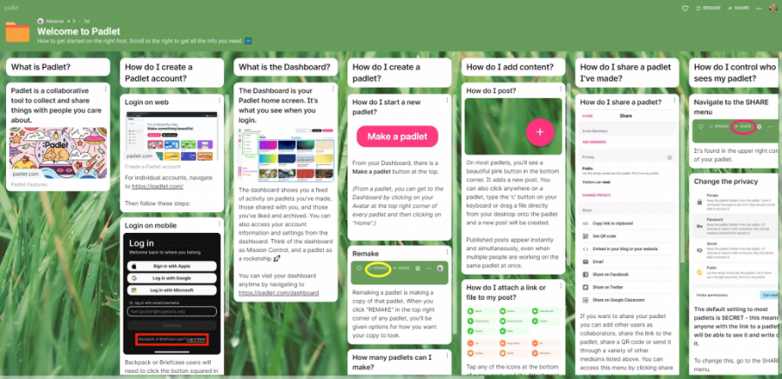

(from <https://teaching-and-learning.hsu.edu.hk/padlet/>)